**PIPLINED DATAPATH**

1. **Thiết kế datapath**

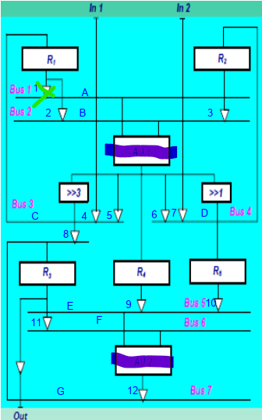

**-**Datapath gồm:

+register (tái sử dụng)

+tri-state (tái sử dụng)

+Right Shifter 1, 3 (tái sử dụng)

+AU1 (có piplined)

+AU2 (có piplined)

1. Thiết kế AU1

|  |  |
| --- | --- |
| CTRL1[1..0] | Function |
| 01 | Abs |
| 10 | Min |
| 11 | Max |

+Schematic:

+Đóng gói:

1. Thiết kế AU2

|  |  |
| --- | --- |
| CTRL2[1..0] | Function |
| 00 | Add |
| 10 | Sub |
| 11 | Max |

+Schematic:

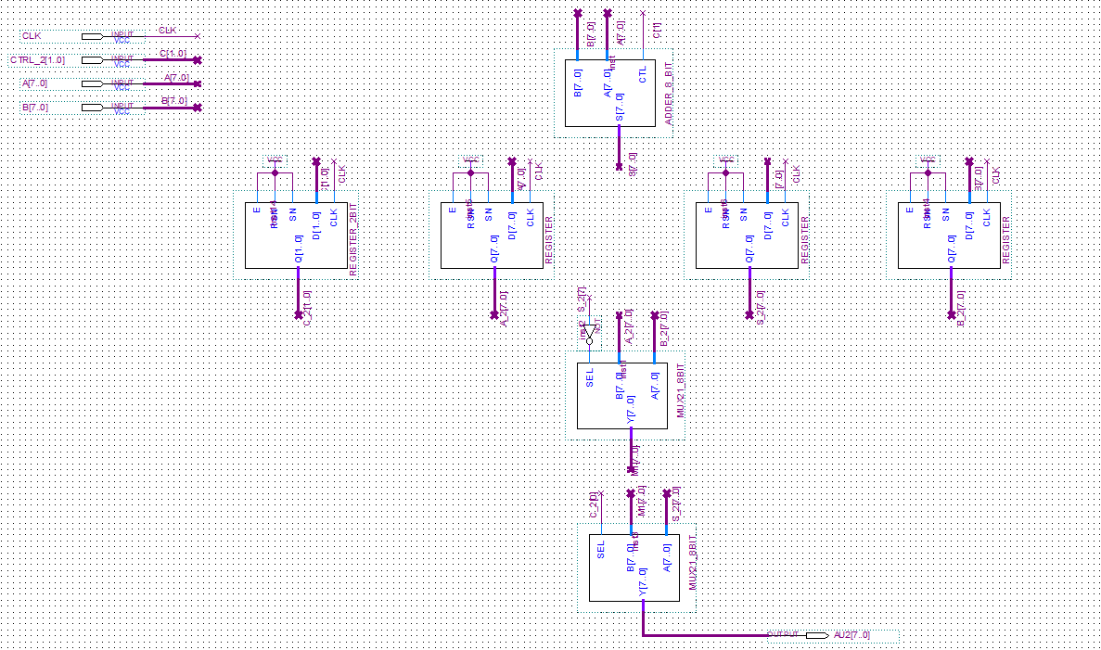

+Đóng gói:

1. Tổng hợp Datapath:

+schematic:

+Đóng gói:

1. **Thiết kế khối controller**
2. Sơ đồ chuyển trạng thái

1. Bảng chuyển trạng thái

1. Mã hóa

1. Bảng giá trị các ngõ ra

|  |  |  |  |  |  |  |  |  |  |  |  |  |  |  |  |  |  |  |  |  |
| --- | --- | --- | --- | --- | --- | --- | --- | --- | --- | --- | --- | --- | --- | --- | --- | --- | --- | --- | --- | --- |
|  | **ER1** | **ER2** | **ER3** | **ER4** | **ER5** | **AU1[1]** | **AU1[0]** | **AU2[1]** | **AU2[0]** | **ET1** | **ET2** | **ET3** | **ET4** | **ET5** | **ET6** | **ET7** | **ET8** | **ET9** | **ET10** | **DONE** |
| **S0** | 1 | 1 | 0 | 0 | 0 | X | X | X | X | 0 | 0 | 1 | 0 | 0 | 1 | 0 | 0 | 0 | 0 | 0 |
| **S1** | 0 | 0 | 0 | 0 | 0 | 0 | 1 | X | X | 1 | 0 | 0 | 0 | 0 | 0 | 0 | 0 | 0 | 0 | 0 |
| **S2** | 1 | 0 | 0 | 0 | 0 | 0 | 1 | X | X | 0 | 1 | 0 | 1 | 0 | 0 | 0 | 0 | 0 | 0 | 0 |
| **S3** | 0 | 1 | 0 | 0 | 0 | X | X | X | X | 0 | 0 | 0 | 0 | 1 | 0 | 0 | 0 | 0 | 0 | 0 |
| **S4** | 0 | 0 | 0 | 0 | 0 | 1 | 0 | X | X | 0 | 1 | 0 | 0 | 0 | 0 | 0 | 0 | 0 | 0 | 0 |
| **S5** | 0 | 0 | 0 | 0 | 1 | 1 | 1 | X | X | 0 | 1 | 0 | 0 | 0 | 0 | 0 | 0 | 0 | 0 | 0 |
| **S6** | 0 | 0 | 1 | 1 | 0 | X | X | X | X | 0 | 0 | 0 | 0 | 0 | 0 | 1 | 0 | 0 | 0 | 0 |
| **S7** | 1 | 1 | 0 | 0 | 0 | X | X | 1 | 0 | 0 | 0 | 1 | 0 | 0 | 1 | 0 | 1 | 0 | 0 | 0 |
| **S8** | 0 | 0 | 1 | 0 | 0 | 0 | 1 | X | X | 1 | 0 | 0 | 0 | 0 | 0 | 0 | 0 | 0 | 1 | 0 |
| **S9** | 1 | 0 | 0 | 0 | 0 | 0 | 1 | 0 | 0 | 0 | 1 | 0 | 1 | 0 | 0 | 0 | 0 | 1 | 0 | 0 |
| **S10** | 0 | 1 | 1 | 0 | 0 | X | X | X | X | 0 | 0 | 0 | 0 | 1 | 0 | 0 | 0 | 0 | 1 | 0 |
| **S11** | 0 | 0 | 0 | 0 | 0 | 1 | 0 | 1 | 1 | 0 | 1 | 0 | 0 | 0 | 0 | 0 | 1 | 0 | 0 | 0 |
| **S12** | 0 | 0 | 1 | 0 | 1 | 1 | 1 | X | X | 0 | 1 | 0 | 0 | 0 | 0 | 0 | 0 | 0 | 1 | 1 |
| **S13** | 0 | 0 | 1 | 1 | 0 | X | X | X | X | 0 | 0 | 0 | 0 | 0 | 0 | 1 | 0 | 0 | 0 | 0 |

1. Khối next-state

-Biểu thức:

-Schematic:

-Đóng gói:

1. Khối present-state

-schematic:

-đóng gói:

1. Khối output

-schematic:

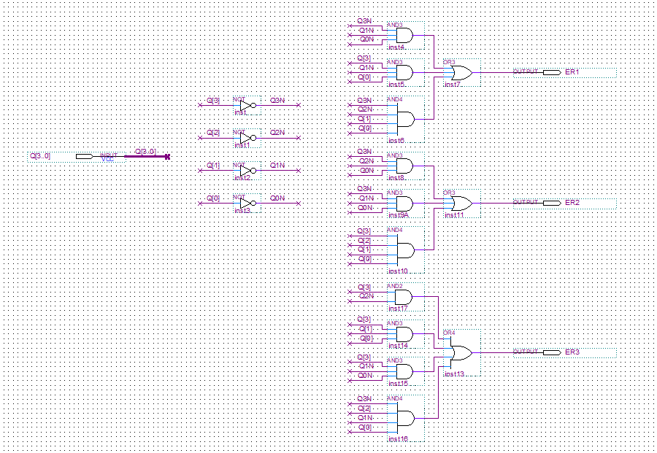

-đóng gói:

1. Tổng hợp controller

-schematic:

-đóng gói:

1. Kết nối toàn hệ thống

-schematic:

-Kết quả mô phỏng:

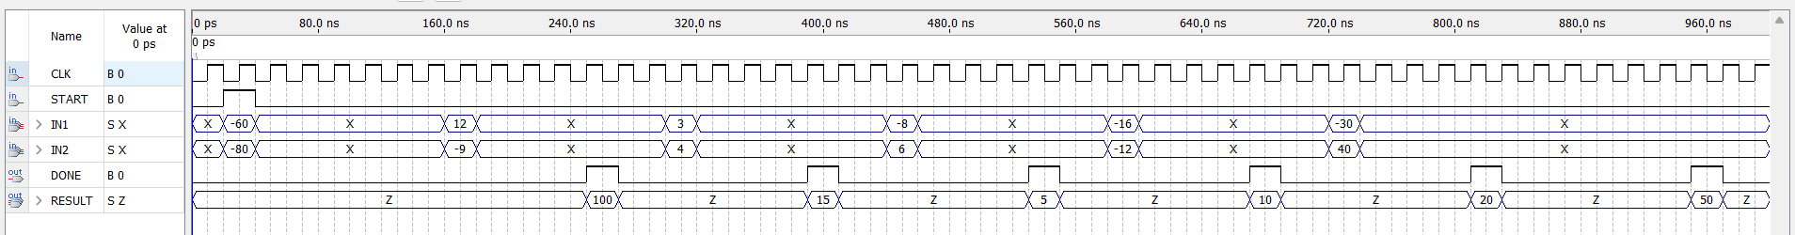

( **Nếu không nhìn rõ thì ông dán 1 hình kết quả wf tổng quát rồi cắt kết quả wf ra làm đôi cho nhìn rõ =)) )**